EXPERIMENT 3

Determination and plotting of Force of attraction between two electric Charges and two parallel conductors separated by varying distance.

Aim:
To Determination and plotting of Force of attraction between two electric Charges and two parallel conductors separated by varying distance between them using SCILAB.

Software required:
•SCILAB version 6.0.1

Program:
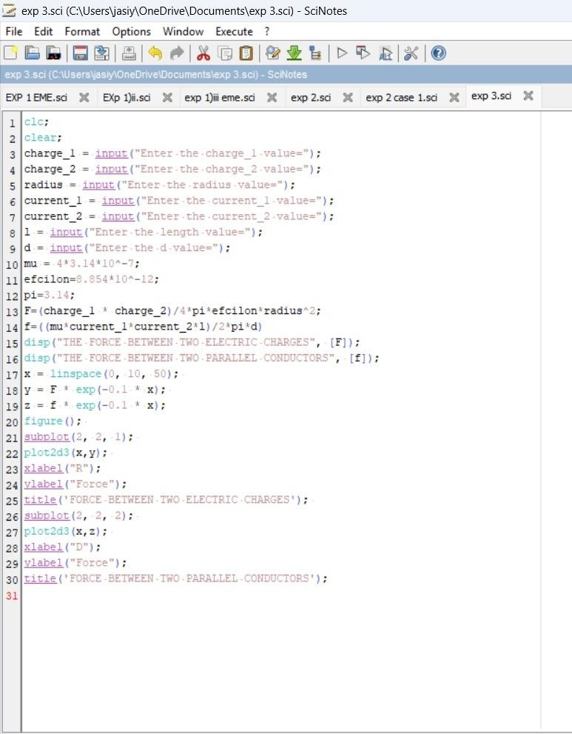

Output:
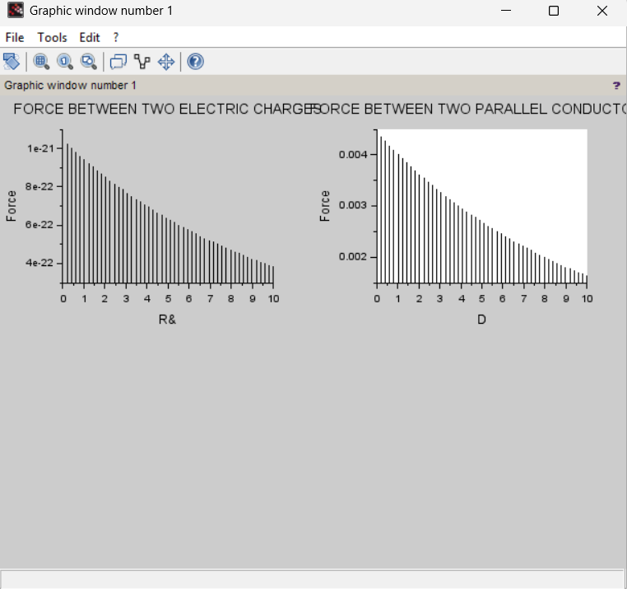
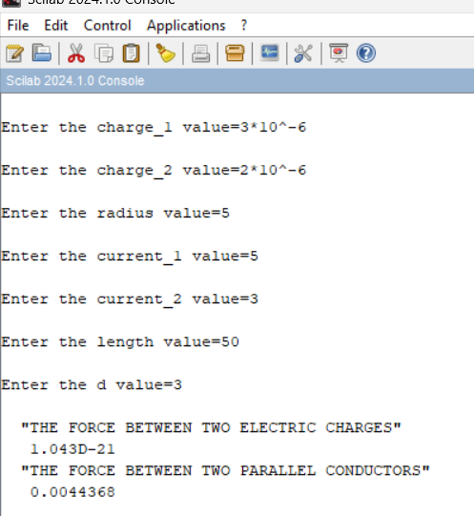

Theoretical calculation:
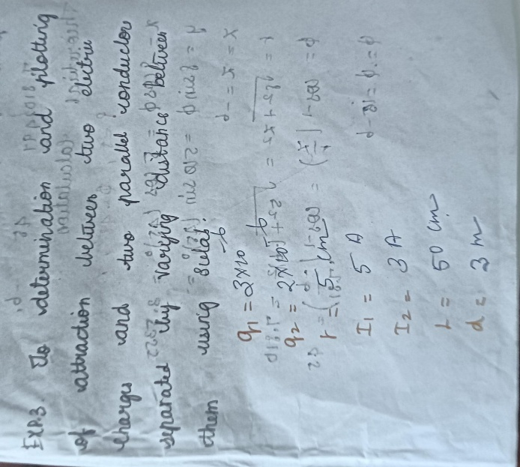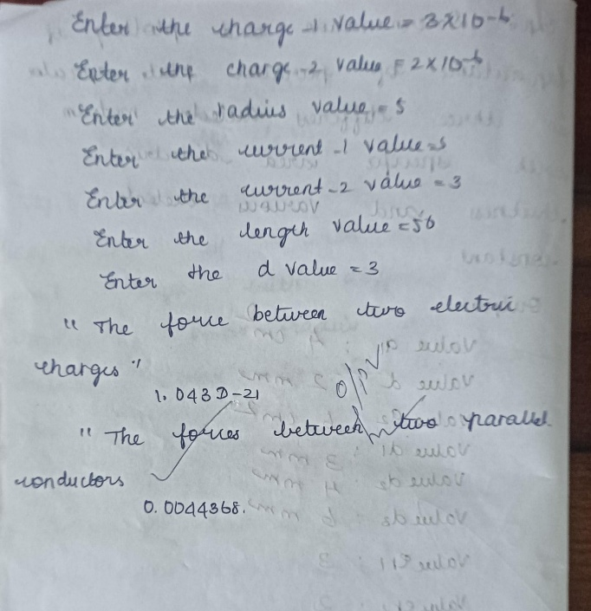

Case 1 :
Given two point charges q1=2×10^−6 and q2=3×10^−6 C, calculate and plot the force of attraction between them as a function of distance, ranging from 0.1 m to 10 m. Explain how the force changes with the distance between the charges.
Code:

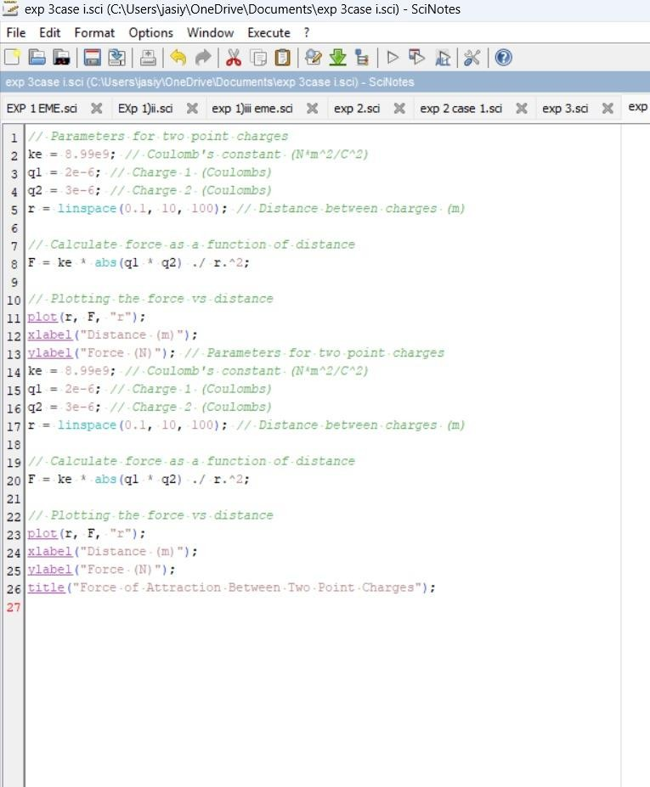
Output:
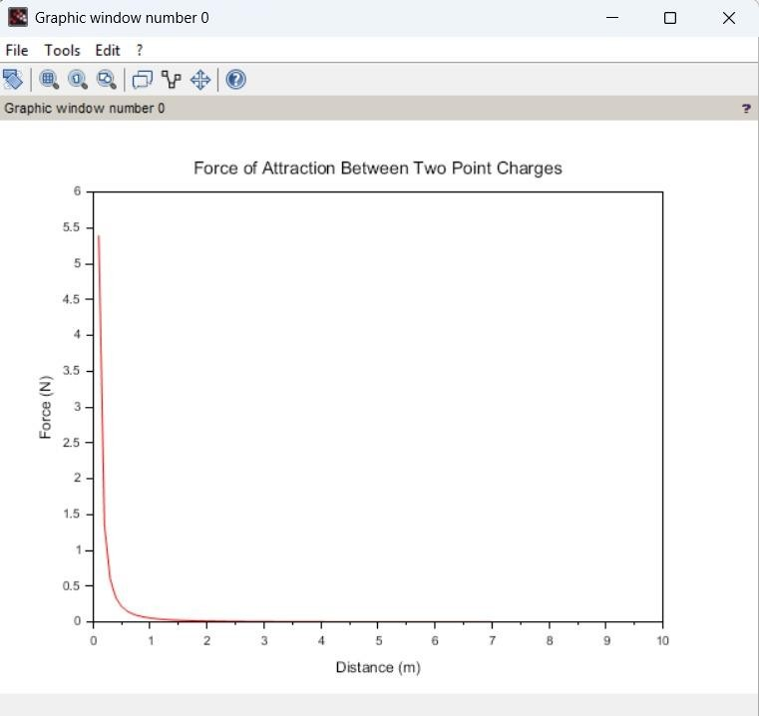

Case 2:
Given two point charges q1=5×10^−6 C and q2=2×10^−6 , calculate and plot the force of attraction between them as the distance varies from 0.5 m to 5 m. Discuss how the force behaves with the varying distance and charge magnitudes.
Code:
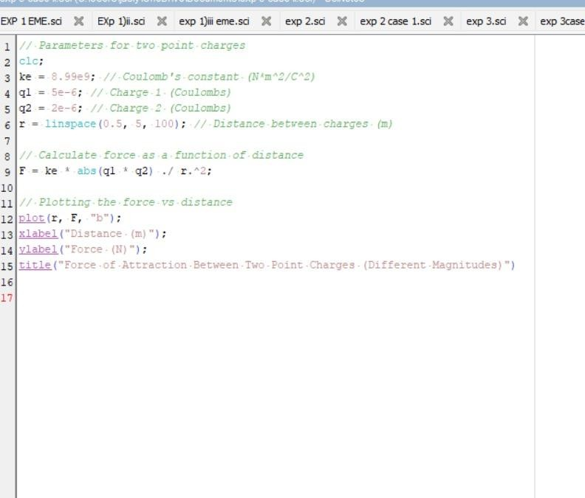

Output:


Case 3:
Two parallel conductors are separated by a distance d. The first conductor carries a current of I1=5 A, and the second conductor carries a current of I2=10 A. Calculate and plot the force per unit length between the conductors for varying distances from 0.1 m to 10 m. Explain how the force changes with the distance between the conductors.

Code:
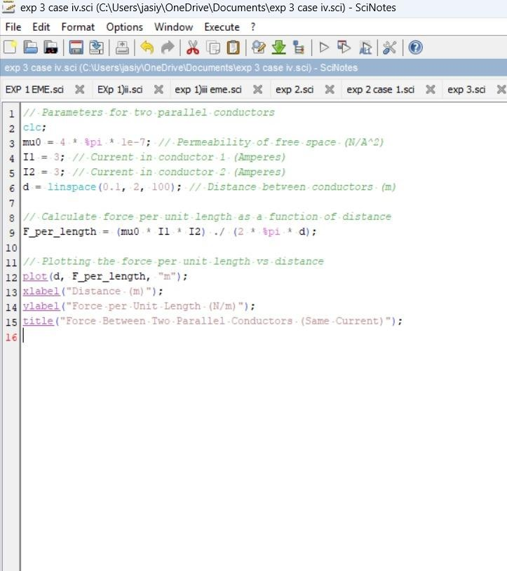

Output:
: 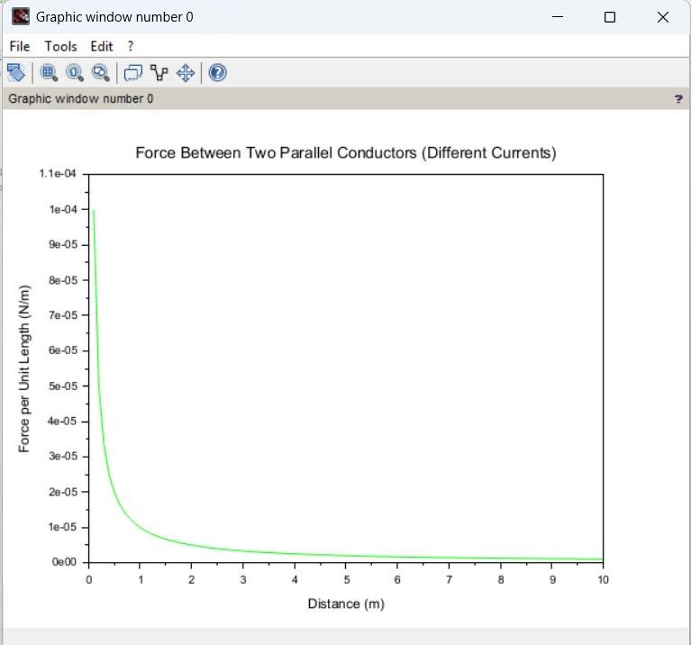

Case 4:
Given two parallel conductors carrying currents of 3 A, calculate and plot the force per unit length between the conductors for varying distances between 0.1 m to 2 m. Discuss the relationship between the distance and the force between the conductors.
Code:


Output:
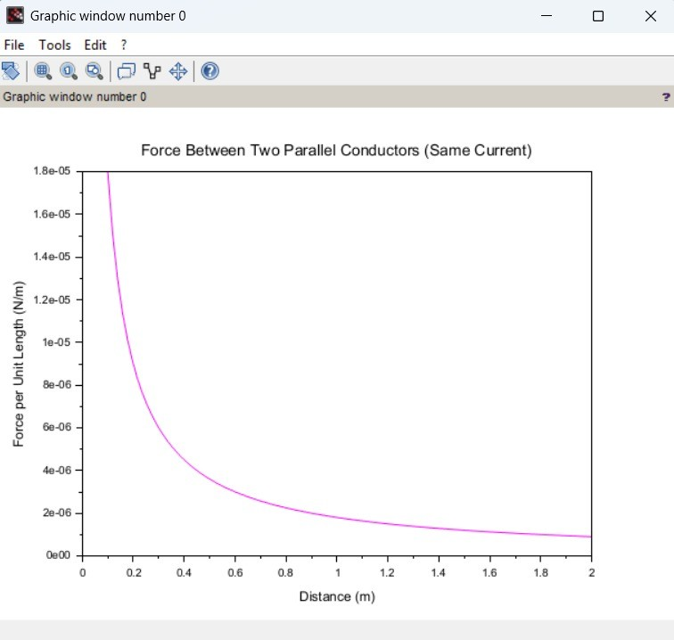

Result :
Thus the program was verified for the force of attraction or repulsion acting along a straight line between two electric charges is directly proportional to the product of the charges and inversely to the square of the distance between them using SCILAB was successfully.

